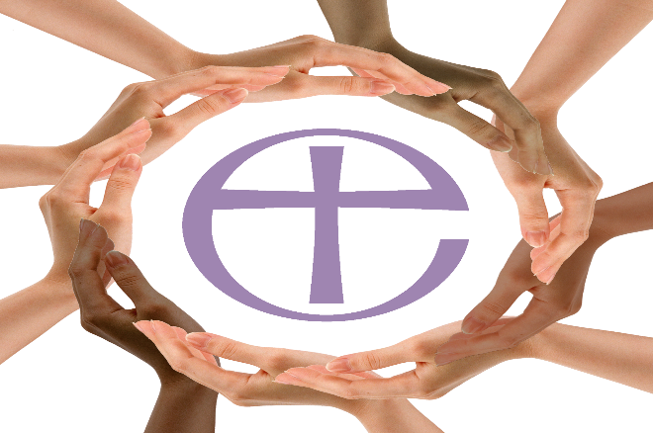

13th October 2020

Celebrating Black History Month in Sheffield Diocese

Reflection – Miriam Cavanagh
Gratitude
This year has been challenging for all, it has been very hard at times to see a glimpse of light through the heaviness and messiness of life let alone to be thankful. The cries of our African American brothers and sisters in USA “I can’t Breathe”, has been haunting every waking moment.

Colossians 3:15-17
^{“15} Let the peace of Christ rule in your hearts, since as members of one body you were called to peace. And be thankful. ¹⁶ Let the message of Christ dwell among you richly as you teach and admonish one another with all wisdom through psalms, hymns, and songs from the Spirit, singing to God with gratitude in your hearts. ¹⁷ And whatever you do, whether in word or deed, do it all in the name of the Lord Jesus, giving thanks to God the Father through him”.
We are called to have faith and hope to believe that God is in all that messiness of life, holding everything together and cheering us on to keep going and to hold on to our Faith in Christ our redeemer and Hope of a better tomorrow that is promised in the Way of the Cross.
God is calling out to His Church, to us as a people of God just like He called to Cain, where are your brother and sisters?
Genesis 4:9-10
“ ⁹Then the Lord said to Cain, “Where is your brother Abel? I don’t know,” he replied. “Am I my brother’s keeper?”¹⁰ The Lord said, “What have you done? Listen! Your brother’s blood cries out to me from the ground”.
The Blood of Abel represents the suffering in our unjust world, a place where only the Love and Light of Christ can overcome this suffering.
We have been challenged to look beyond our own needs and care for those in margins of society, especially those affected by Covid-19 pandemic, food poverty and racism in our Churches and wider community
This second week of Black History Month we give thanks to all our Key Workers, NHS Staff, Scientists, Teachers, Supermarket workers, Council workers, Care Workers, Police Officers, our Leaders, our Neighbours, and our Churches working alongside the wider community of people of God in our Diocese and wider world.
Lord of Peace we bring before you our gratitude for our brothers and sisters who have gone before us doing their service in building your kingdom here on earth.

Prayer
Loving God, we thank you for calling us to you, from all corners of the world, to come home to belong. We appreciate your love that embraces all of us. We thank you that we are all one in you. We thank you for your faithfulness and justice. When we were aliens and foreigners you welcomed us. We thank you for calling us to your ministry, to live and do your work with the mind of Christ. Remind us that we are here to fulfil your calling to serve. Help all we do be done for love. During this year’s Black History Month, we want to draw closer to you. Amen
2© 2013 The United Church of Canada

